PRESS RELEASE

AZL Aachen GmbH in cooperation with Institute of Plastics Processing (IKV) in Industry and the Skilled Crafts at RWTH Aachen University

Aachen/Germany  
August 28, 2017

**Group of companies invests in future of SMC**

**A consortium of international companies joined forces to drive the future of Sheet Molding Compound (SMC), an established and cost-efficient material for the production of lightweight components. The companies will kick off a joint Market and Technology Study on September 12, 2017 which will pave the way for establishing a new high-performance generation of SMC materials (High-Performance SMC). Companies along the entire SMC value chain as well as those interested in the SMC technology are invited to join.**

To increase the lightweight potential of SMC materials and thereby open up additional applications for fiber-reinforced plastics in highly cost-driven sectors such as the automotive sector, a next generation of High-Performance SMC (HP-SMC) is required. These high-performance materials consist of short and continuous carbon and glass fibers and combinations of these as well as customized resin compounds. In comparison to other materials, HP-SMC value chains are determined by a high number of interdependencies between material, processing and application properties which are both challenge and potential and will be addressed in the upcoming study.

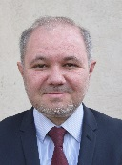Dr. Thierry Renault, Manager of Partnerships at Faurecia Composite Technologies: “SMC is without any doubt “the” composite technology that is trusted by the automotive industry. There is for sure a strong renewed interest for standard SMC and also for its many evolutions and innovations that are now referred as High-Performance SMC. The industry needs to clearly define the potential, advantages and drawbacks for new products that can be targeted for with these materials. The AZL platform relies on the strong scientific background of the Aachen University and research institutes and its industrial members to give us a better view of where the market of High-Performance SMC is going.”

 Peter Schmidt, Managing Director of Polynt in Miehlen, Germany also emphasizes the importance of taking SMC to the next level: “SMC has a long history at Polynt. We joined the study as the AZL offers us a platform to develop a high-performance version of SMC with enhanced raw materials, recipes and processes. This will allow us to open new application areas or to reactivate existing applications. In our view, it is important that at the AZL members of the entire value chain – from raw material to OEM – are actively involved in this initiative over the next months.”

The aim of the Joint Market and Technology Study on High-Performance SMC is to provide in-depth knowledge on SMC applications, technologies and simulation methods. Key challenges, and technological solutions for establishing High-Performance SMC in markets with high demands on performance, predictability, reliability and costs are identified. This will serve as basis for the elaboration of design guidelines, a target-oriented development and to open up new business opportunities. The 12-months study is designed as a joint study involving players along the entire value chain. This approach allows participants to benefit from the knowledge of all study partners and experts who are involved in the project and to influence the progress according to their specific demands. During the kick-off meeting on September 12, key materials, applications as well as calculation and production technologies will be discussed by the participants to focus the study.

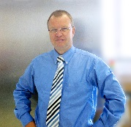SMC is a traditional and important process for large-series which can achieve an attractive price-performance ratio by using new resins and fibers. We, at Mahr Metering Systems develop new metering and mixing techniques to replace batch processes with continuous processes. The target is to achieve increased flexibility of the recipe and constant quality of the production process. The AZL Platform offers us the opportunity to discuss requirements of the process with established SMC producers and processors,” states Dr. Reiner Karl, Managing Director of Mahr Metering Systems GmbH.

Scope and content of the study have been developed in close collaboration with the industrial AZL Workgroup as one of different joint research and development initiatives to build a “toolbox” for HP-SMC. For the realization of their initiatives, the workgroup uses the large-scale and test equipment available on the RWTH Aachen Campus, one of them being the 1,800 tons Schuler composite press installed at AZL, as well as the IKV expertise in processing as well as process and structure built up over many years. Future development challenges identified from the study, can therefore be realized in short-term development projects on site.

**More Information on the Study and Kick-Off Meeting**

Brochure: [www.lightweight-production.com/go/high-performance-smc-study](http://www.lightweight-production.com/go/high-performance-smc-study)

Kick-Off Meeting: [www.lightweight-production.com/go/hp-smc-kick-off](http://www.lightweight-production.com/go/hp-smc-kick-off)www.lightweight-production.com/go/smc-information-event

**Pictures**

Download of high-resolution pictures:

<http://azl-aachen-gmbh.de/wp-content/uploads/2017/08/Pictures_SMC-Kick-Off_AZL.zip>

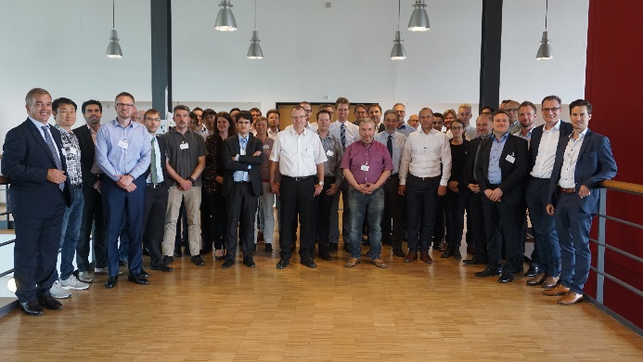Bild 1: During an information event in May 2017, the AZL Workgroup on “High-Performance SMC” together with companies interested in the study discussed and sharpened the content of the study. *Copyright: AZL Aachen GmbH*

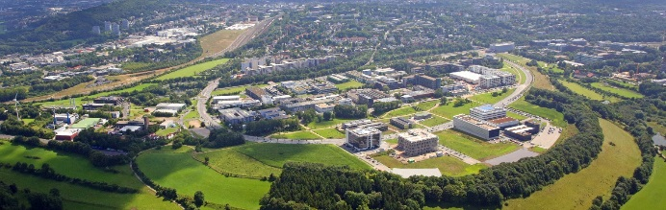Picture 2: Competences and hardware along the entire SMC process chain are represented at the RWTH Aachen Campus.   
*Copyright: Campus GmbH/ Steindl*

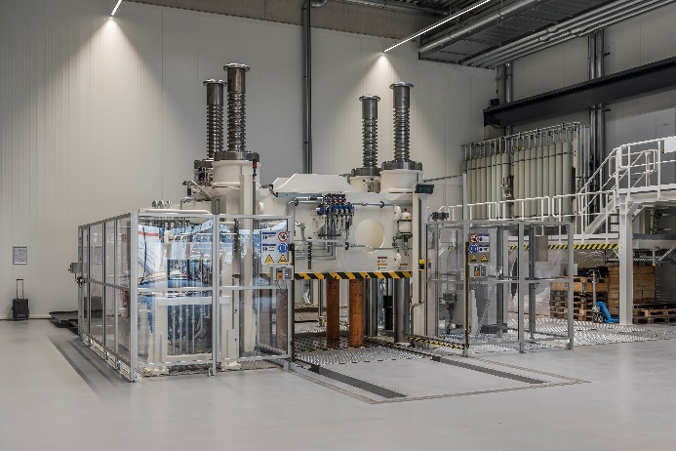Picture 3: Large-scale industrial manufacturing equipment for SMC is also available in AZL´s new research facility at RWTH Aachen Campus and will be used for future projects. *Copyright: Schuler Pressen GmbH.*

**About AZL:**

RWTH Aachen University is one of the worldwide leading universities in the field of production technology. The Aachen Center for integrative Lightweight Production (AZL) of RWTH Aachen consolidates the lightweight expertise of eight partner institutes with 750 scientists on the RWTH Aachen Campus. The AZL builds an international partner network between these institutes and more than 70 international companies involved in lightweight production.

For this, AZL consists of two separate entities: The AZL of RWTH Aachen University addresses the transformation of lightweight design in mass production with basic research and development of lightweight products, materials, production processes and systems with access to the latest full-scale machines and automation systems. As a service provider partnering with companies in the field of lightweight production technology, AZL Aachen GmbH provides industrial services in the areas of engineering, consultancy and project management, networking and business development. With the AZL Partnership, the AZL Aachen GmbH enables the close cooperation between the lightweight industry and the research institutes of RWTH Aachen Campus along the whole value chain. The AZL Partner Network consists of more than 80 industrial partners representing the entire lightweight production value chain from the raw material producer, over molders, manufacturing equipment suppliers, Tier 1 and Tier 2 to OEMs, from SMEs to large multinational corporations, from Germany to Mexico, China or Japan, from 21 different countries in total.

**www.azl.rwth-aachen.de  
www.lightweight-production.com**

**About IKV:**

IKV, the Institute of Plastics Processing at RWTH Aachen University, is Europe-wide the leading research and education institute engaged in the field of plastics processing enjoying outstanding reputation. More than 300 staff are employed in finding solutions to problems connected with processing, materials technology and part design in the plastics and rubber industries. IKV's close contacts with industry and science, together with its outstanding facilities, enable cutting-edge research in plastics technology and ensure that students benefit from a comprehensive, practically oriented course of study. Plastics engineering graduates from IKV are thus sought-after experts in industry. In organisational terms, IKV is divided up into the four specialist departments of Injection Moulding, Extrusion and Rubber Technology, Part Design and Materials Technology, and Composites and Polyurethane Technology. The institute also takes in the Centre for Analysis and Testing of Plastics, and the Training and Further Education department. IKV is run by an Association of Sponsors, which currently has a membership of about 290 plastics companies from all over the world. Univ.-Prof. Dr.-Ing. Christian Hopmann is Head of the Institute and Managing Director of the Association of Sponsors. He also holds the Chair of Plastics Processing at the Faculty of Mechanical Engineering at RWTH Aachen University.

**www.ikv-aachen.de**