PRESS RELEASE

AZL Aachen GmbH in cooperation with CONBILITY® GmbH and RWTH Aachen University

Aachen/Germany  
September 5, 2017

**Energy Storage Systems – Worldwide Joint Market and Technology Study on Technological Key Enablers**

**AZL Aachen GmbH launches an international Joint Market and Technology Study which provides a detailed market insight in technologies and the variety of energy storage systems. The study will be realized in cooperation with RWTH Aachen University and CONBILITY® GmbH. The BVES Bundesverband Energiespeicher e.V. (German Energy Storage Association) supports the targets of the study which will start in November 2017. Companies seeking new business opportunities in the field of energy storage systems are invited to join.**

The Joint Market and Technology Study on “Energy Storage Systems” is motivated by the strong market growth which is apparent for energy storage systems. Energy storage systems will be one of the most attractive and fastest growing technology markets with almost countless facets. Without energy storage, the globally unstoppable transmission of energy supply by renewable energy will not be accomplished. Apart from production and transport, the storage of energy is the key technology for establishing intelligent networks on the basis of renewable resources. Furthermore, decentralized energy storage systems offer enormous potential for increasing the energy efficiency of households and industrial productions. Finally, the systems are the condition to enable a reliable access to electrical energy for humans in developing countries.

Figures underline the relevance: The market volume in Germany is expected to grow from about 2.5 million euro in 2011 to approximately 14 million euro in 2025 (Source: www.statista.com, 2015).

The study has a strong focus on the technological analysis of established, emerging and still developing systems and technologies and will therefore offer a broad decision basis for the business development of companies. The results will be relevant for suppliers of materials, of processing technologies as well as of systems and machinery who want to evaluate the potential of their products, their production technologies as well as their know-how in the field of energy storage systems.

Urban Windelen, federal chairman of the BVES: “Representing the interests of companies from the sector and as a political adviser, our most important targets are reducing barriers and supporting fast growth of energy storage systems. We are expecting important impulses for our members from this study and in particular an impact on the market entry of companies providing important key technologies without utilizing them for the dynamically growing market of energy storage systems.”

The study will start with a detailed market segmentation including an assessment of the economic and technological potential, the technology readiness level as well as important key players. All the important technologies in the field of energy storage, chemical energy storage as well as thermal energy storage are considered. The team of experts will then identify use cases in the field of energy supply, of operating energy grids as well as of mobile and permanent decentralized applications. Different system configurations, materials and components will be analyzed with the aim to identify technological enablers. The study will additionally reflect supply chains (supplier of systems, materials and technologies) and business models with future technological potential and requirements.

As the study is designed as a joint study involving players along the value chain, participants exchange and network with other industrial project participants from different branches and market sectors as well as with external experts. Study participants will be a direct part of the study and will be able to influence the progress according to their specific demands.

The study will be kicked-off in November 2017 with a duration of eight months. Interested companies can join before the kick-off Meeting in November. Details on the study procedure and outcome as well as options for joining are given at this link: <http://azl-aachen-gmbh.de/energy-storage-systems-study-brochure>

**Pictures**

Download of high-resolution pictures:

<http://azl-aachen-gmbh.de/wp-content/uploads/2017/09/3_Pictures_Energy-Storage_AZL.zip>

Picture 1: Energy storage systems are one of the key enabler for renewable energy requiring very diverse technologies. These are addressed in the study in order to analyze established, emerging and still developing systems and technologies.

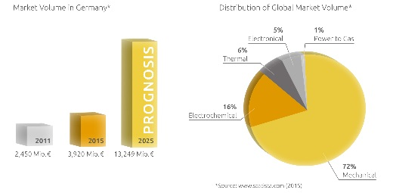Picture 2: The market volume in Germany for energy storage systems is expected to grow strongly within the next years. *Copyright: CONBILITY® GmbH, Source: www.statista.com (2015)*

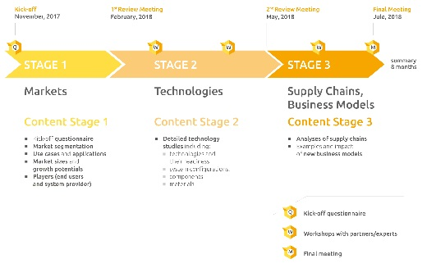

Bild 3: The 8-month Joint Market and Technology Study on “Energy Storage Systems” will address markets, technologies, supply chains and business models during the three study stages. *Copyright: CONBILITY® GmbH*

**About AZL Aachen GmbH:**

Partnering closely with the RWTH Aachen University, one of the worldwide leading universities in the field of production technology, AZL Aachen GmbH supports its customers as the interdisciplinary and holistic solution provider to analyze, understand and develop their products, processes and markets. The AZL offers a platform as well as projects to exchange knowledge and to effectively drive innovation by sharing effort. The industrial services include studies and benchmarks, technology advisory as well as development projects. For this, AZL Aachen GmbH its strong network at the RWTH Aachen Campus, which is one of the biggest research landscapes in Europe for enterprises and research institutions. At the Campus, 260 research institutes and more than 4,500 scientists develop the most advanced applications, materials and production methods on over 800,000 m2.

**www.azl-aachen-gmbh.com**

**About CONBILITY®:**

CONBILITY® GmbH is an award winning spin-off of RWTH Aachen University, Europe´s leading Excellence University in the field of production technology. Combining market and technology knowledge (material, production methods, production systems) with process optimization along the entire value chain, CONBILITY® consulting services include market analysis, consulting for material selection or qualification, technology consulting, as well as process cost analysis, and process optimization.

**www.conbility.com**