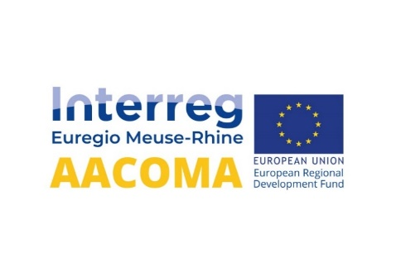

Press release Oct 2023

***Interreg Project AACOMA Closure event the 21/09 in Liège***

The AACOMA project came to its end in September 2023. A Closure Event was therefore organized on September 21 in the Park Inn Hotel at Liège Airport. Invitees met for a walking lunch before the beginning of the event in the ‘Saint Exupery’ room.

**Michael Effing** from AMAC welcomed all participants, representants from Interreg Meuse-Rhine, company representatives and project partners to this afternoon session.

**Jean-Philippe ODEURS**, Senior Program Manager of Interreg Meuse-Rhin addressed some welcome words and congratulated the AACOMA team for the successful project realized by project partners CENTEXBEL, SIRRIS, ULIEGE, FLANDERSMAKE, UMAASTRICHT, FONTYS AND AMAC during the last 45 month.

**Axel NOEL**, director of the Liège Province Regional Antenna, took the word and informed the public about the new Interreg 6 program and new coming calls in 2024.

**Bernard PAQUET**, project coordinator, presented the main achievements and deliverables of the AACOMA projects, organized events, communication activities, awareness making activities, realized demonstrators and sustainable actions. Promoting the interactivity with companies, identifying their needs and challenges, and addressing technological challenges were highlighted. The strong cooperation between partners and the effective support from the Interreg Joint Secretariat contributed to this successful project.

Lessons learned through the exchange with the Composite Community in the Meuse Rhine region were presented by Michael Effing, CEO of AMAC and responsible for the communication in the AACOMA project. From a generated database of more then 500 companies, more then 80 companies joined the AACOMA community on the project website. To make awareness to companies, 6 roadshows were organized with matchmaking sessions and training workshops. An Advisory committee was set in place and consulted regularly. By conducting 2 surveys on future needs, we learned about gaps and needs of companies. From the exchange with companies, 5 demonstrator concepts were chosen and worked out during the project. The informations collected from matchmaking sessions and organized surveys entered in the gap analysis that was realized for sustainable actions.

**Yoland Dams**, responsible for the work package on sustainable actions from FlandersMake, gave an overview of the gap analysis and the roadmap that was workout. It focuses on the area of materials, processes, overall needs and future challenges. Potential ideas for follow-up projects were developed in this roadmap.

We concluded at the end of the AACOMA project that composite manufacturing industries in the Meuse-Rhine region are facing a lot of challenges in the future. New technologies and digitalization solutions offer possibilities to enhance the state of the art in this region. Future actions and new follow-up projects, based on developed demonstrators, are captured, and further shaped into projects.

All informations can be shown on the AACOMA website [<https://aacoma-interreg.eu/>](https://aacoma-interreg.eu/)

**The AACOMA Project**

The design of innovative materials and their state-of-the-art implementation offer great opportunities to SMEs for the development of new products. The objective of the AACOMA project, an Interreg Euregio-Meuse-Rhin project, which runs for 3 years until mid of 2023 with a budget of 3M€, is to network SMEs with technological research partners.

Seven partners from the three countries are carrying out the project: CENTEXBEL is the project leader and is supported by the University of Liège, SIRRIS and Flanders Make in Belgium, as well as from FONTYS, the University of Applied Sciences and AMIBM from Maastricht University in the Netherlands and AMAC in Germany.

More information on our website: <https://aacoma-interreg.eu/>

Contacts:

Bernard Paquet, R&D Manager “Technical Textiles & Composites”, CENTEXBEL

*Coordinator of the AACOMA project*

[bernard.paquet@centexbel.be](mailto:bernard.paquet@centexbel.be)

+32 (0) 474 68 10 92

Mona Ziegler, Marketing and Communications Director AMAC GmbH

[Amac-communications@effing-aachen.de](mailto:Amac-communications@effing-aachen.de)

+49 (0) 151 651 79 021

Partners :

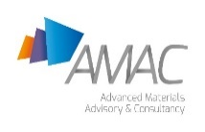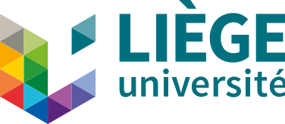Co-financed by :

