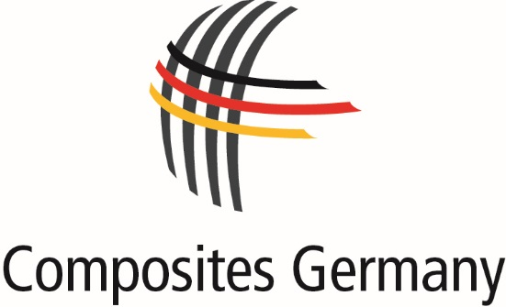

**PRESS RELEASE**

December 2017 – No. 05/2017

**Composites Germany confirms Chairman of the Board and Spokesperson for the Management for 2018**

At the last Board meeting of the trade association Composites Germany on   
20 November 2017 Michael Effing, PhD, Chairman of the Board of the Federation of Reinforced Plastics (AVK) and Managing Director of AMAC GmbH, was confirmed in his office as Chairman of the Board of Composites Germany.

At the same time Elmar Witten, PhD, Managing Director of AVK was confirmed as Chief Executive Officer of Composites Germany.

Both will serve in their respective capacities for another year.

Dr. Michael Effing, Chairman of the Board of Composites Germany and AVK: "I am honoured to have been elected Chairman for the fourth successive time by the four associations CCeV, CfK Valley, VDMA and AVK. It is expected that 2017 will be a record year with approx. 7 % growth. In Europe, our industry will generate more than € 32 billion in sales from a volume of nearly 3 million tonnes of composites. These figures confirm the important role played by the composites industry not just as a key technology but also as a powerful growth market for Germany and Europe. It is vital that we and our more than 820 member companies work together with research institutes to advance our industrial R&D projects and continuously improve competitiveness.”

**Photo: Copyright AVK**

Photo no. 1: Dr. Michael Effing 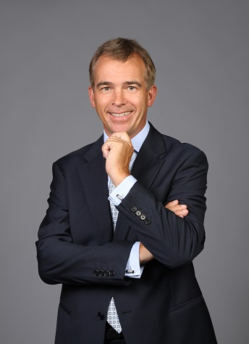   
Photo no. 2: Dr. Elmar Witten C:\Users\monahardinghaus\AppData\Local\Microsoft\Windows\INetCache\Content.Word\Photo 2-Dr. Elmar Witten.tif

Contact for press enquiries: Composites Germany, Mona Hardinghaus; Tel. +49 (0)69 2710770, Email: [Mona.Hardinghaus@avk-tv.de](mailto:Mona.Hardinghaus@avk-tv.de);  
[www.composites-germany.org](http://www.composites-germany.org)

**About Composites Germany**

Through the trade association “Composites Germany”, the four major organisations in the fibre composites sector aim to strengthen the German composites industry, particularly in the field of research, determine common positions and take account of overlapping interests.

AVK - Federation of Reinforced Plastics e.V. (AVK), Carbon Composites e.V. (CCeV), CFK Valley e.V. and VDMA use Composites Germany as a forum to bundle their abilities with more than 820 member companies and promote the future-oriented themes of high performance composites and automated production technology which are particularly relevant in Germany.

Further information available at: [http://www.composites-germany.org](http://www.composites-germany.org/)