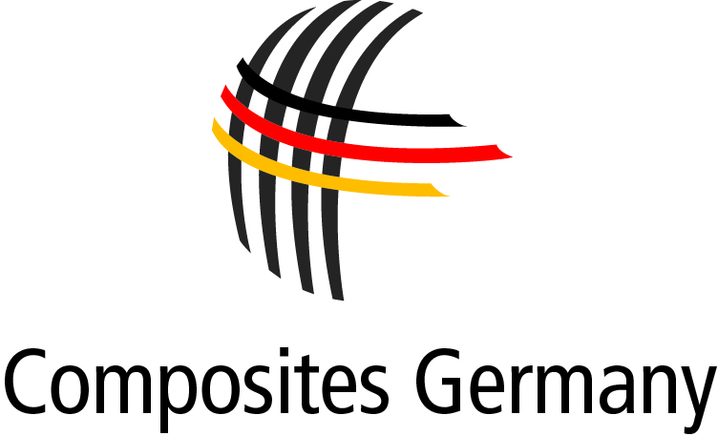

**P R E S S R E L E A S E**

October 2014 – No. 05/2014

**New Composites Germany Conference 2015: "Composites – On the Path to Becoming a Key Industry?"**

Düsseldorf. At Composites Europe 2014, Dr. Michael Effing, who has been re-elected as Chairman of Composites Germany for a further year, announced the business association's concept for a new Composites Germany conference under the working title "Composites – On the Path to Becoming a Key Industry?". The conference will highlight the aspects of the industry that generate innovations and can contribute to the transformation of the composites sector into a key area of the national economy. "I am delighted and honoured to have retained the trust of my colleagues, who have elected me to this office once again. Over the coming year I wish to dedicate my energies, above all, to making the first edition of this conference a great success," says Effing.

The production of a joint event concept was one of the priorities defined by the business association Composites Germany when it was founded last year. This plan is now being implemented.

Like the AVK conference it replaces, the new Composites Germany conference will take place as the prelude to the Composites Europe trade fair, which will next be staged in Stuttgart in 2015. "Composites are an important area for high wage countries such as Germany. We see a need for a separate conference to focus attention on this highly relevant subject –

independently of special interests. At the same time, we do not wish to overload the event market, which is already relatively full, with an additional conference," says Dr. Elmar Witten, Spokesman for the Management of Composites Germany and Managing Director of AVK. In terms of lectures, presentations and visitors, the conference will be even more international than the previous AVK event. This reflects the general trend of growing international competition in the composites industry.

The other members of the board of Composites Germany, Dr. Stefan Schlichter (VDMA), Dr. Reinhard Janta (CCeV) and Prof. Axel Herrmann (CFK-Valley) explained that the following innovation factors will be major subjects of the conference:

efficient processes, outstandingly qualified employees, partnerships between industrial companies and between industry and research institutes, standards and standardisation, market transparency and responsible care.

Hans-Joachim Erbel, CEO of Reed Exhibitions, the organiser of Composites Europe, believes the new concept is a logical extension of the existing partnership between the conference and the trade fair – especially in order to boost the international character of the event as a whole.

**Copyright Graphic: AVK**

**Press enquiries: Composites Germany,** Dr. Elmar Witten, Spokesman for the Management

Tel. +49 (0)69/27 10 77-0, Email: [elmar.witten@composites-germany.org](mailto:elmar.witten@composites-germany.org);  
[www.composites-germany.org](http://www.composites-germany.org)