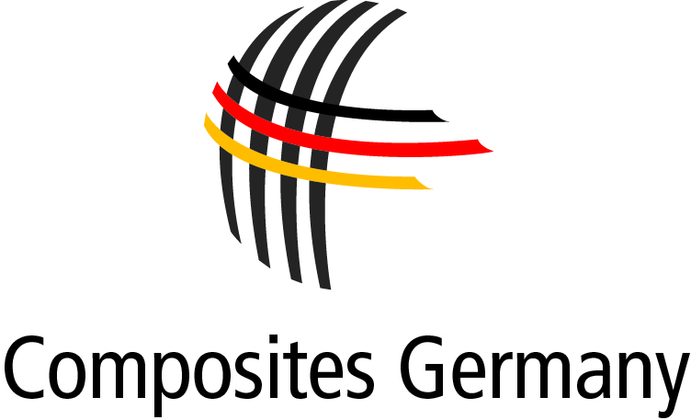

**P R E S S R E L E A S E**

June 2014 – No. 03/2014

**Composites Germany: Standardization Portal Composites goes online after successful partner conference**

Potential applications and opportunities for fibre reinforced thermoplastic structures were highlighted at the Composites Germany Conference on 20 May 2014. Over 100 participants - primarily from Composites Germany's member organisations AVK, CCeV, CFK-Valley and VDMA Forum Composites Technology - travelled to the event at the Aachen Centre for Integrative Lightweight Production (AZL) to gather valuable information about new applications and innovative technological implementations. As well as attending the programme of lectures and tours of the AZL facility areas involved in the composites process chain, many visitors took advantage of "matchmaking" events that provided a forum for exchanging ideas and experiences.

Dr. Michael Effing, Chairman of the Board of Composites Germany, also presented the strategic orientation developed by the trade association, which was founded in 2013. "Germany is the leading supplier for lightweight construction using composite materials across many industries," says Effing summarising the organisation's vision and emphasising the key objectives of its mission: building a strong, national representative body for the composites industry in Germany, promoting innovation and new technologies, developing new markets and value added chains and extending apprenticeships and professional development programmes.

The website [www.composites-germany.org](http://www.composites-germany.org) provides more detailed information on these objectives as well as the newly launched "Standardization Portal Composites". This portal is produced in cooperation with the German Institute for Standardization

(DIN) and provides information on national, European and international standards for fibre reinforced plastics that have been published or are under development. This new and unique source of information for the composites market supports the existing standardisation work conducted by Composites Germany.

**Press enquiries:   
Composites Germany,** Dr. Elmar Witten, Spokesman for the Management

Tel. +49 (0)69/27 10 77-0, Email: [elmar.witten@composites-germany.org](mailto:elmar.witten@composites-germany.org);  
[www.composites-germany.org](http://www.composites-germany.org)