# C:\Users\ElmarWitten.AVK-TV\AppData\Local\Microsoft\Windows\Temporary Internet Files\Content.Outlook\J5C4RQ1I\logo_cg.jpg

# **P R E S S R E L E A S E**

September, 17th, 2013 – No.01/2013

**A new trade association is born – Composites Germany**

Stuttgart. The four major organisations within the German fibre reinforced composites industry have announced the foundation of a joint umbrella organisation at the Composites Europe 2013 trade fair: together they will form the trade association ***Composites Germany***. The founding members of Composites Germany, which is based in Berlin, are AVK – Industrievereinigung Verstärkte Kunststoffe e. V. (AVK), Carbon Composites e. V. (CCeV), CFK-Valley Stade e. V. (CFK-Valley) and Forum Composite Technology in the VDMA (VDMA).

The purpose of this new umbrella organisation is to strengthen the German composites industry and research, define joint positions and identify common interests. The member organisations will remain separate and independent. However, they will join forces in areas of special relevance in Germany, such as high performance composites and automated production techniques.

The organisation will focus its attention on areas such as public relations and representing the industry's interests, promoting technology and innovation, participating jointly at trade fairs and developing event and training concepts. A biannual survey of all the member companies of the founding associations on the subject of market information was conducted for the first time in July 2013. Work is also already in progress on the theme of standardisation with particular attention being paid to material properties and testing procedures.

Dr. Michael Effing, Chairman of the AVK and Managing Director of AMAC has been elected Chairman, a role which will rotate each year between the member associations. "Composites are a key technology for Germany and this technology has to stay. Especially in the field of lightweight materials and integrated production technologies for high wage countries it is important that the four leading composites organisations work closely together and represent the interests of their members with one voice," says Michael Effing.

Dr. Elmar Witten, Managing Director of the AVK, was elected Spokesman for the Management of Composites Germany. "The new Composites Germany website ([www.composites-germany.org](http://www.composites-germany.org)) presents the organisation and its activities. But it also enables everyone with an interest in the area of composites to communicate effectively with the relevant partners in the industry," says Elmar Witten.

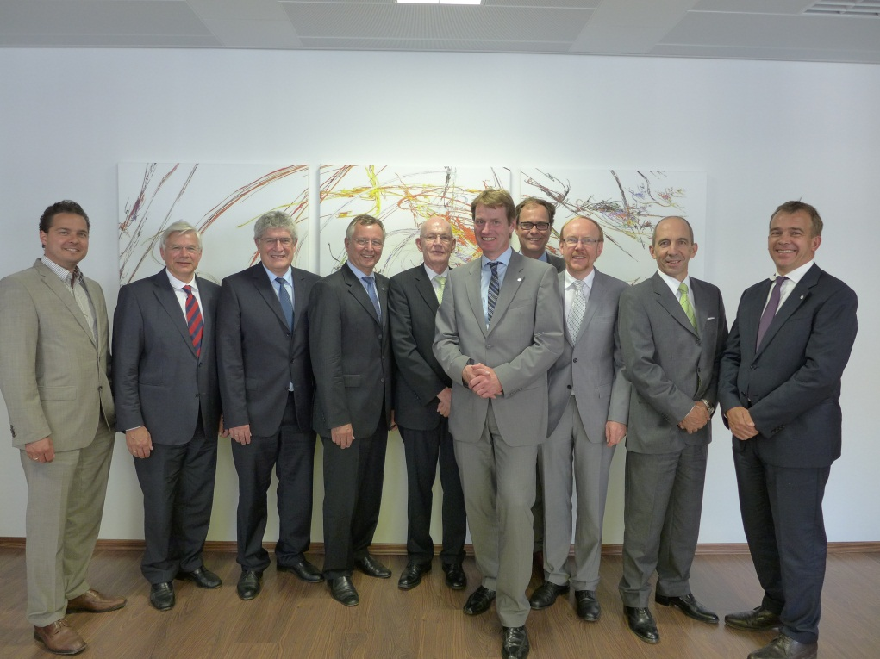

Photo: The members at the founding meeting of Composites Germany, from left to right: Patrick Markert, Prof. Axel Herrmann and Dr. Dieter Meiners (CFK-Valley), Dr. Reinhard Janta and Dr. Hans-Wolfgang Schröder (CCeV), Dr. Elmar Witten (AVK), Thorsten Kühmann, Dr. Walter Begemann and Thomas Waldmann (VDMA), Dr. Michael Effing (AVK).

**Press enquiries: Composites Germany,** Dr. Elmar Witten, Spokesman for the Management

Tel. +49 (0)69/27 10 77-0, E-Mail: [elmar.witten@composites-germany.org](mailto:elmar.witten@composites-germany.org);  
[www.composites-germany.org](http://www.composites-germany.org)