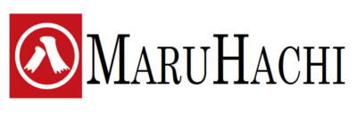

Fukui, Japan and Aachen, Germany, February 2021

MaruHachi: New focus on high-temperature thermoplastic tapes and laminates for Aerospace and other high-end applications - New line installed

With their recently installed high-temperature unidirectional tape line, Japan-based composites manufacturer MaruHachi enables new opportunities for high-end applications in demanding market segments like aerospace, automotive or others outperforming traditional materials based on PP and PA which are already widely available.

In the first phase, MaruHachi will produce up to 40 tons/year and focuses now specifically on high-temperature thermoplastic uni-directional (UD) tapes and multi-layer sheet laminates. The material is based on high-performance fibers like carbon, aramid, glass or natural fibers and the matrix can be high-performance polymers like PPS, PEEK or other higher temperature polymers, which are much tougher than epoxies and easy to recycle. With a width of 500 mm, a specific weight from 60 to 350 g/m2, depending on the chosen material, the lines can operate under temperatures up to 420 degrees Celsius. Working under these extremely high temperatures allows for better material properties of the final application, higher performance, increased resistance and integrated high-performance functionalities e.g. by overmoulding.

Since 2017, MaruHachi Group is active in the European market in cooperation with Dr. Michael Effing,the CEO of AMAC GmbH, who advises and supports the company strategically. The established, family-owned MaruHachi Group has a strong history in automotive and medical textiles and has been active in the innovative composites market for more than 15 years.

Toshi Sugahara, CEO of MaruHachi: “For many years, we have already been cooperating with domestic and international partners on high-demand applications and therefore, MaruHachi decided now to invest over 1 million EUR in this new line in phase 1, including a funding participation from the Japanese government NEDO. New developments in phase 2 will be be undertaken by end of 2021 on the downstream technologies like the automated preforming and consolidation. With our new products, we want to contribute to significant weight reductions of the final products, thus improve energy efficiency while offering a cost-efficient and high-quality solution.”

Dr. Effing, CEO of AMAC GmbH confirms: „The focus on the niche of high-temperature products based on PPS and PEEK allows MaruHachi on very demanding high-end applications such as structural frames on space and aircrafts, aircraft seats or engine components etc. The tapes are fully recyclable and can be processed e.g. with high-speed with laser-based tape placement machines and robots.”

Picture New Line at MARUHACHI in Fukiu / Japan
© MaruHachi
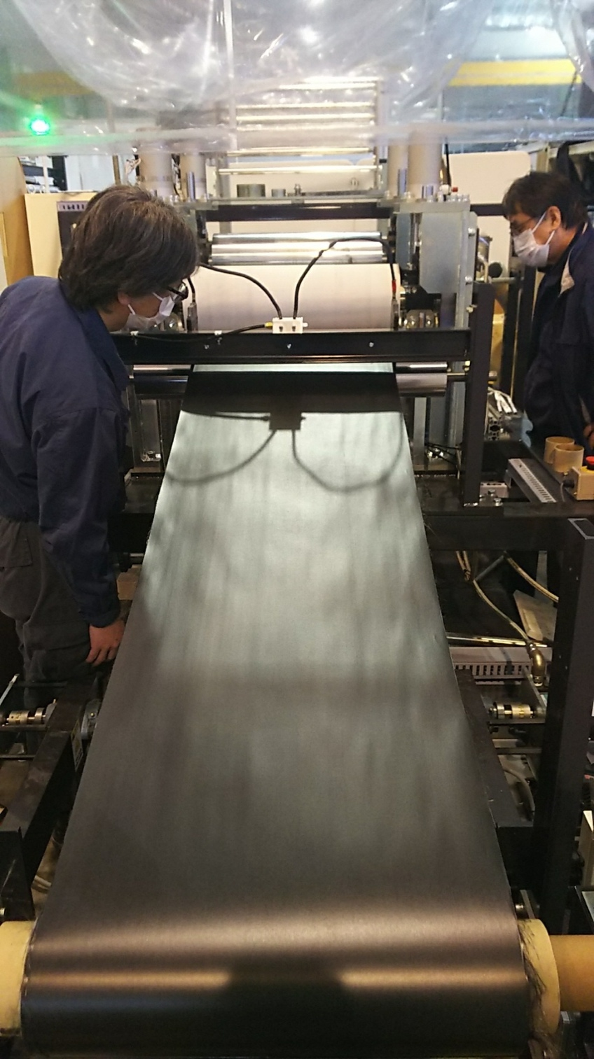

About AMAC
AMAC GmbH is an Industrial and Business Consulting Company in the field of lightweight construction materials based in Aachen, Germany. The business model of AMAC is based on three pillars: establishment and development of networking and clusters between universities and industrial companies, Sales and Business development excellence as well as management of industrial projects in the field of
innovations and commercialization. Dr. Michael Effing is Chairman of the board of the trade associations Composites Germany and AVK.
www.amac-international.com

About MARUHACHI
MaruHachi Group with its headquarters in Fukui, Japan, founded in 1936, is a family-owned developer and manufacturer of composite materials with 80 employees, who was traditionally active in textiles. Some 15 years ago, MaruHachi decided to diversify into the fascinating sector of advanced materials, namely into the thermoplastic composites sector, in form of tapes, sheets and near-net shaped preforms. This business is being expanded into the European market since most of the innovations are coming from that region. The offering includes products based on unidirectional reinforcement glass, carbon and aramid fibers with matrices ranging from PE, PP, TPU, PA6, PA/L, PPS, PEI, PES, LCP to PEEK. MaruHachi is member of AVK and AZL. In 2014, MaruHachi has won the JEC Innovation Awards for their high-pressure vessels.
https://maruhachi.eu

Your contact:
Mona Ziegler
Marketing Director AMAC GmbH
Amac-communications@effing-aachen.de
+49 (0) 151 651 79 021

