April 16th, 2020

**Market Outlook**

Additive Manufacturing, or 3D Printing is the dynamic New Platform Technology that is sweeping the world, especially now, with the SARS Covid 19 pandemic disrupting global supply chains. Many firms are evaluating Additive Manufacturing technologies as a serious option to shortening supply chains.

The graph below shows the actual and forecasted worldwide market revenue of the additive manufacturing / 3D printing industry in billion US dollars (Wohler’s Associates, 2019).

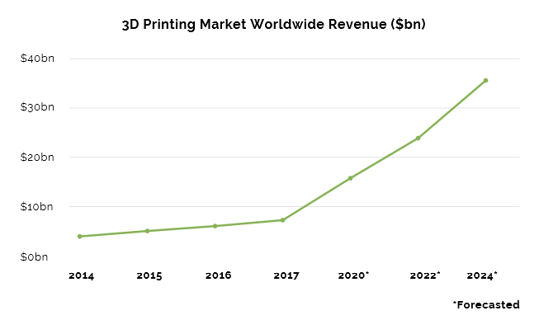

**New Players**

One area of additive manufacturing that has not slowed down is the growth of new startups. There are new businesses coming to market with variations of existing technology, even on the FDM, SLA and SLS printing technologies. Additionally, new technologies are starting to emerge within the market.

The actual and predicted growth is largely powered by a rise in the amount of new companies entering the industry. Throughout 2018, the amount of companies

producing and selling industrial AM systems increased to a significant 177, equal to a 31% increase (Wohler’s Associates, 2019).

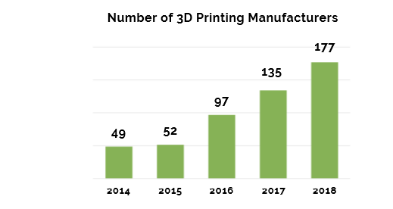

**Trends**.

With the maturation of many applications, a shift towards serial production and industrialization can be seen in many industrial applications. Also, AM serial production can compete with traditional parts especially where complex geometries are combined with low volume or variable demand. With a focus on part to part quality, there is a growing demand for quality control solutions that can integrate with traditional quality assurance processes

As a result of this market penetration, companies are now able to publish case studies of additive manufacturing and can state in which areas they have achieved sustainable business. As a result, more commercial uses of the AM technology are growing every day.

**Consultancy and Advisory Services**

Our focus is in helping our clients navigate solution based on Plastics and UV resin materials and printing technologies

Working together, we’ll help you navigate the vast range of solutions, identify a specific solution and find the right expertise to implement it.  
  
No matter where you are in your 3D printing journey, we can help you identify, test and implement an optimal solution for your needs.

Focus Areas.

**Strategy Consulting**: We can help you identify the impact of 3D printing on your business – demonstrating the ways 3D printing can reshape your strategy.

**Product innovation**: We’ll help you analyses where 3D printing can support or expand your product portfolio.

**Technology deployment**: We can help with the identification the firms, processes and tools needed for to successfully deploy 3D printing.

**Applications Consulting & Validation**: we’ll help you find the optimal solution for your product, give every project the best chance of success with the latest developments in 3D printing processes and materials. We shall help you analyze the technical and economic feasibility of 3D printing for your specific manufacturing needs.

**Design optimization**: We can engage industry experts, working closely with your design teams to help them understand 3D printing and design so your teams can realize the potential of their designs.

**Operations Consulting**: We can analyses where and how 3D printing can fit into your current or future workflow.

**Operational improvement**: We can analyses the benefits of additive manufacturing in your total operations recommending options to move traditional parts to AM Technologies, improving your overall flexibility and cost.